**Lab manual 11!**

**Arrays**

**Task 1:**

Write a C++ program to input elements in an array and print all negative elements.

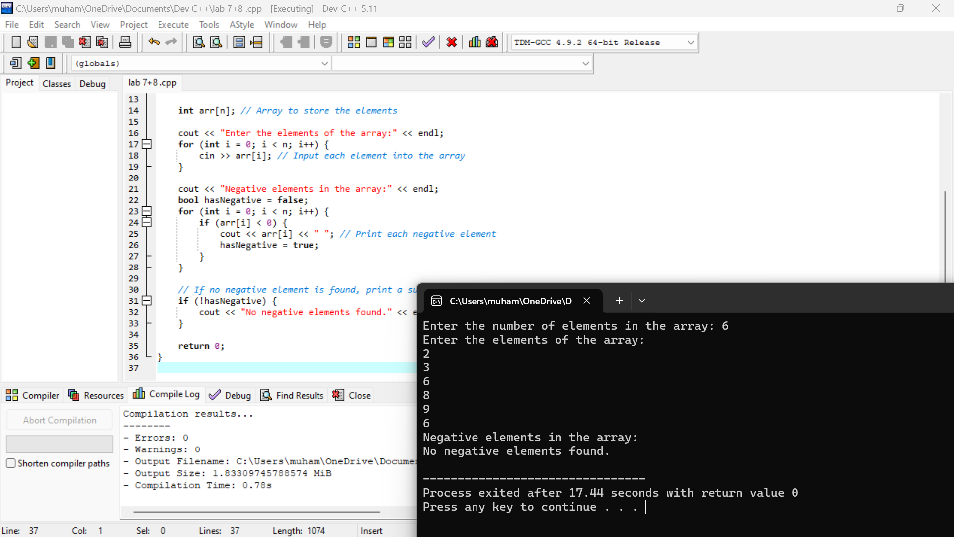

**Task 2:** Write a C++ program to read elements in an array and find the sum of array elements.

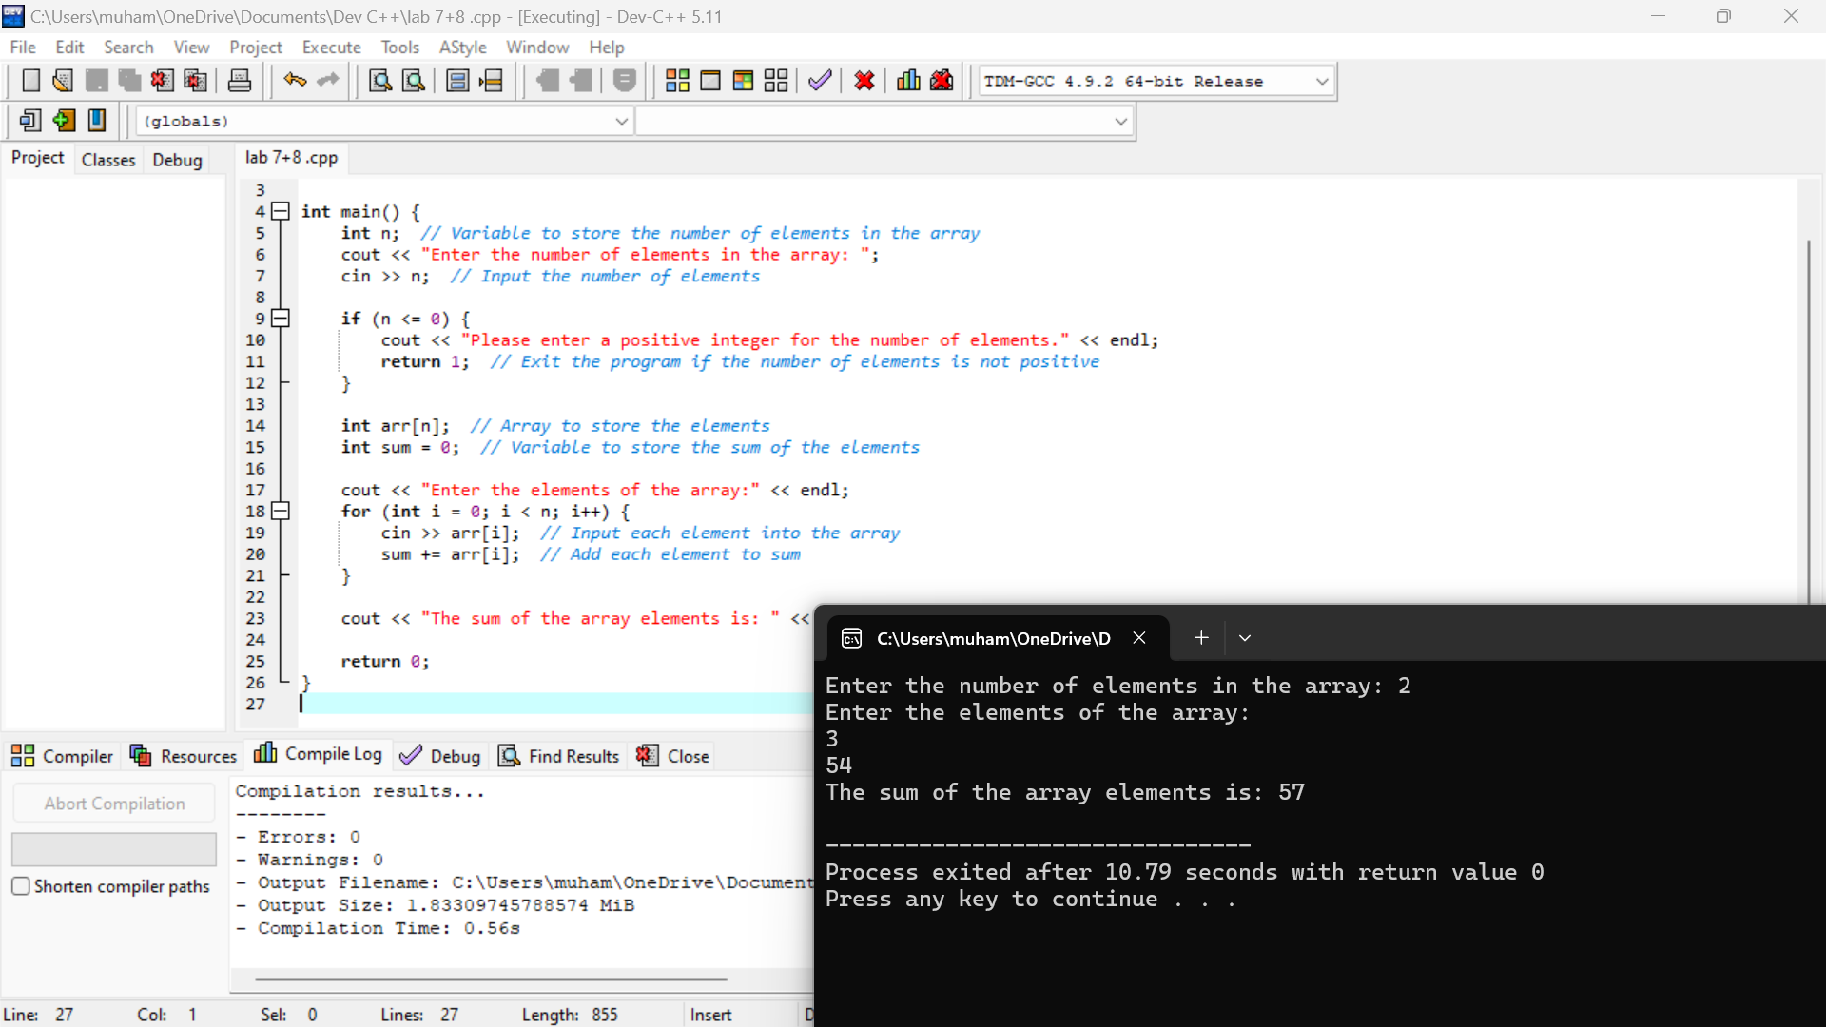

**Task 3:**

Write a C++ program to input elements in an array from the user and count even and odd elements in the array.

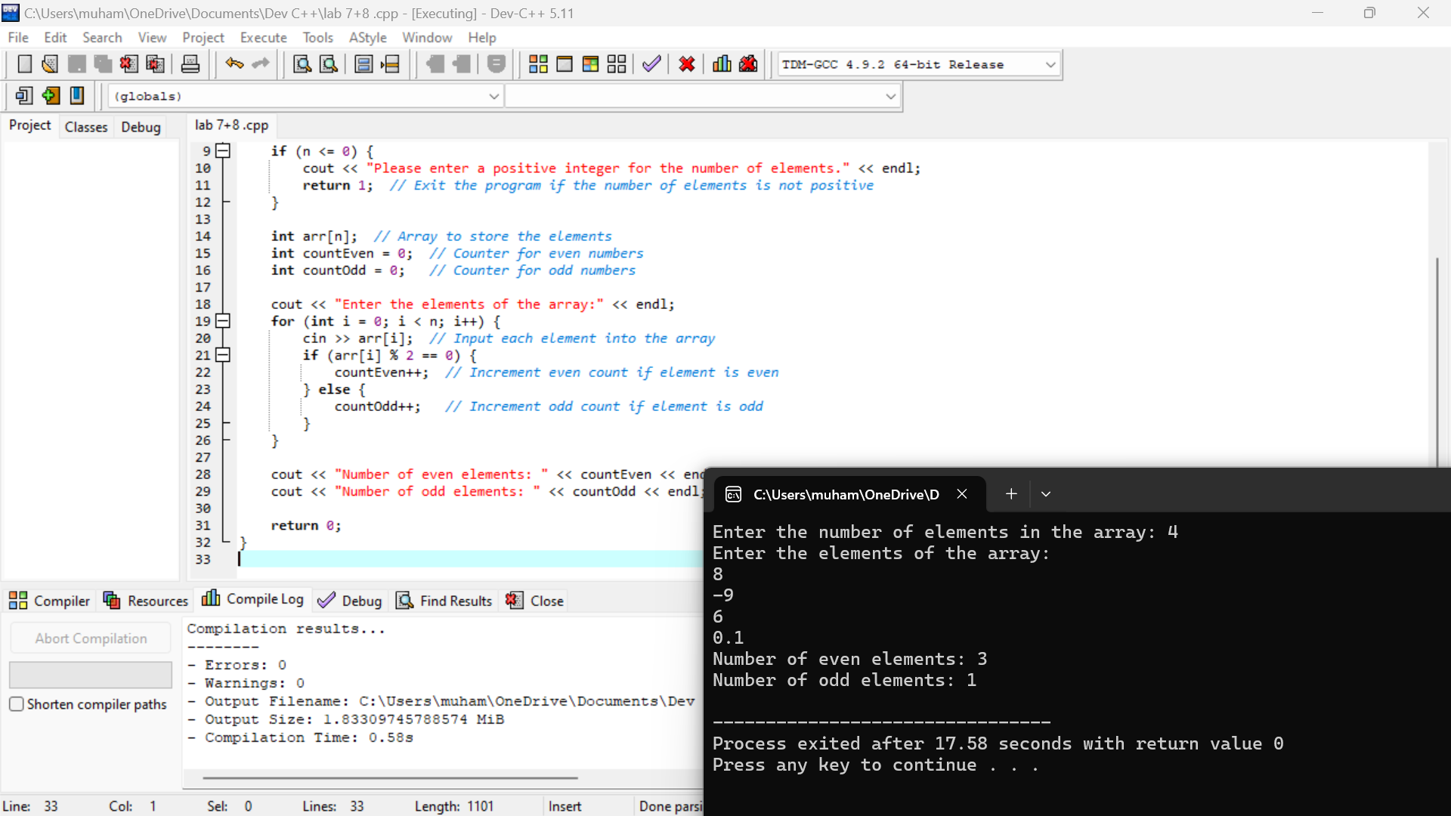

**Task 4:**

Write a C++ program to input elements in an array and copy all elements of the first array into the second array.

